CEDARWOOD SYSTEM FUNCTIONAL SPECIFICATION FOR FUND VIEW

Revision history

| Revision Date | Summary of Changes | Version No. | Author |
| --- | --- | --- | --- |
| 11 August 2015 | Initial Draft | Version 1 Draft 1 | Maria Lotsman |
| 15 August 2015 | Added the business rules, marked questions with yellow within the document. | Version 1 Draft 2 | Maria Lotsman |
|  |  |  |  |

# Document structure

The document provides information about Library view for the Cedarwood application. The document called Functional package – has the description of the library functionality. Parts of the document labeled as *FP_US#Name which means: Functional Package 1 User Story 1 Search.*

# Functional package 3 Fund view

The application provides possibility to work with Fund documents in order to understand the financial state of the specific client. Funds are created as a part of a project. To view/manage/add fund the *Fund view* functionality shall be developed.

## Fund view functionality

Please, see the UC diagram to understand basic functionality that is provided for user.

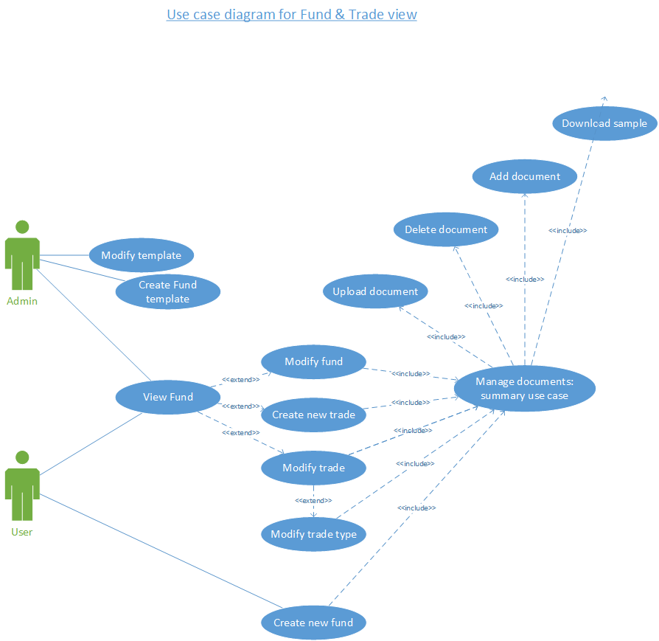

A Fund is defined and described via a collection of documents. This collection of documents or template is specific to client. For every client there is only one fund template and such template can include:

The Private Placement Memorandum(s)

* Fund(s) Financial Statements
* Valuation Policies & Procedures
* Risk Free Rate Assumptions
* Benchmark Spreads
* Others

The Fund Template will allow an Admin to define the default collection of documents expected for a Fund. When a project is created, the default documents will be added to the project definition and the Admin can add or remove expected documents. This allows the client to see what has been provided and to easily determine what documents are outstanding. By tracking expectations versus delivery, Managers can easily see which projects are stalled by document collection and which documents are stalling them. When a Fund is created, the date by which the documents are expected will be set and the system will notify the client of any outstanding documents just prior to that date and again after the date has passed.

### Fund management workflow (user)

Please, see below the workflow for Fund & trade. Please, be aware the current workflow describes only the Fund workflow from user (not admin) perspective.

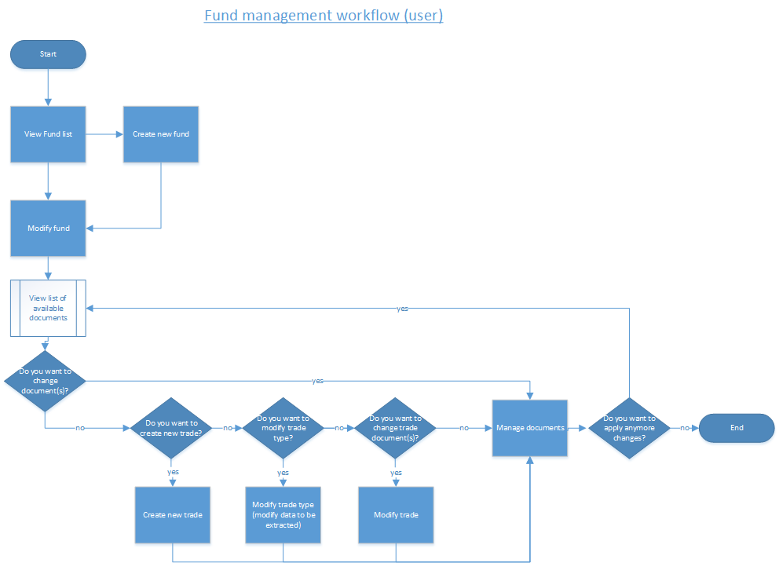

#### Create fund

User shall have a possibility to create a fund. Fund is created from a fund template which is assigned to a user.

|  |  |
| --- | --- |
| **Fund template** | **Description** |
| List of expected documents | Expected documents to be turned in by this client with a description for the every document which is required. |
| Sample of the document | Sample of the required document |
| Link to the document | Available when document is loaded to the system by user. |
| Due date for the documents | A date within which OR before which document need to be provided. |
| Report template | Used as an output |

The system will notify the client of any outstanding documents just prior the due date and immediately after the due date. The client user can also mark a document as unavailable and provide a reason as to why. There will be a single, organization-wide Fund template which stores the starting values to use anytime a new Fund is created.

### Fund: business rules

|  |  |  |
| --- | --- | --- |
| **#** | **Business rule description** | **UI connected** |
| FND_001 | Fund always assigned to one project. Several funds can be assigned to one project. | See the [Cedarwood_Trade_Fund_view](http://rygbwf.axshare.com/#p=cedarwood_trade_fund_view&c=1) |
| FND_002 | Each fund has a predefined set of the documents. This set of documents is defined by a template. Template is assigned to a client user by administrator. Only one template can be assigned to a client. | See the Create new Fund modal window description |
| FND_003 | If the set of the predefined documents changes, user get the notification about this. | - |
| FND_004 | Each fund has a trade. Trade can be added and then modified. Trade amount is not limited. | See the [Fund 1 view information](http://rygbwf.axshare.com/#p=fund_1_view_information&c=1); and UI description within this document  Fund view |
| FND_005 | User can upload additional documents to the Fund documents. | See the [Fund 1 view information](http://rygbwf.axshare.com/#p=fund_1_view_information&c=1); and UI description within this document  Fund view |
| FND_006 | User can download sample documents where those available. | See the [Fund 1 view information](http://rygbwf.axshare.com/#p=fund_1_view_information&c=1); and UI description within this document  Fund view;  See the Create new Fund modal window description |
| FND_007 | If the document is included by admin in the fund OR trade template, then the document need to be available as a sample. | See the [Fund 1 view information](http://rygbwf.axshare.com/#p=fund_1_view_information&c=1); and UI description within this document  Fund view;  See the Create new Fund modal window description |

### Trade description

A Trade is a collection of Transactions which were performed as part of the Fund’s strategy.

Since a fund can embody multiple strategies and, therefore, multiple types of Transactions we use the concept of a Trade to unify the Transactions into a consistent analysis approach.

Trade Type is used as a template for a Trade and serves as a way to set the defaults for the Trade, but these defaults can be changed to the specific values required by the Trade. A Trade Type is a template for the analysis of a Trade. The type can be specified by a user and changed later. A trade type defined which documents user need to provide, this is a set of documents which support the transactions or their possibility.

User can:

* Create new
* Delete
* Change type
* Edit documents within the trade (download/delete)
* Edit data to be extracted
* Create new type of trades(admin)
* View sample (get info/download)

#### Trade business rules

|  |  |  |
| --- | --- | --- |
| **ID** | **Business rules** | **UI connected** |
| TRD_001 | Several trades can be included in one fund. |  |
| TRD_002 | Trade type can be changed. When trade type changes, list of required document and data to be extracted also changes | Please, see modify trade |
| TRD_003 | User can upload the documents for the trade. | Please, see the create new trade and modify trade |
| TRD_004 | User can download samples | Please, see the create new trade and modify trade |
| TRD_005 | User can upload additional document (?) | Please, see the create new trade and modify trade |
| TRD_006 | User gets the visual notification is the document need to be uploaded ASAP both in trade editor view and in trade list view. | Please, see modify trade and Trade list |
| TRD_007 | User can create several trades with the same name & type within the system (?) |  |
| TRD_008 | User can upload the documents from the already available within the system (the once that he has access to) to be assigned to this trade |  |

### Transaction description

As stated above, a Trade is a collection of Transactions so a Transaction can be thought of as the smallest part of a Trade which can be analyzed. Going from the bottom of the hierarchy to the top, the value of the Transactions represents the value of a Trade and the value of the Trades represents the value of the Fund. Since a Transaction is a portion of a Trade, each Transaction should be analyzed based on the documents and summary data defined by the Trade.

Analysts and Associates will spend a majority of their time processing Transaction data based on the Trade structure defined by the Manager. Since the Trade structure is defined, once the Transactions are identified the system can calculate which documents are required and provide status tracking as to the analysis process. As Analysts and Associates complete their work, Managers can review it, and all of this becomes visible within the management console. Once the documents and extracted data are defined, there becomes a clear connection between the report data and the source of that data which provides the transparency described in the Background section above.

## UI Fund list view

Please, see below the screen map for the Fund list view:

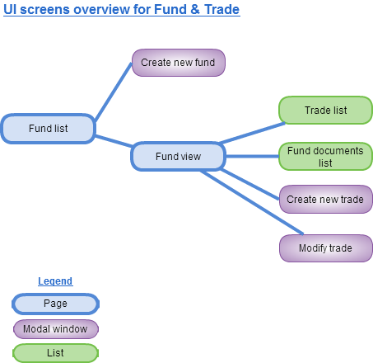

### Fund list view

Fund view allows user to view and manage information about the specific funds. Please, see the wireframe for [Fund list view](http://rygbwf.axshare.com/):

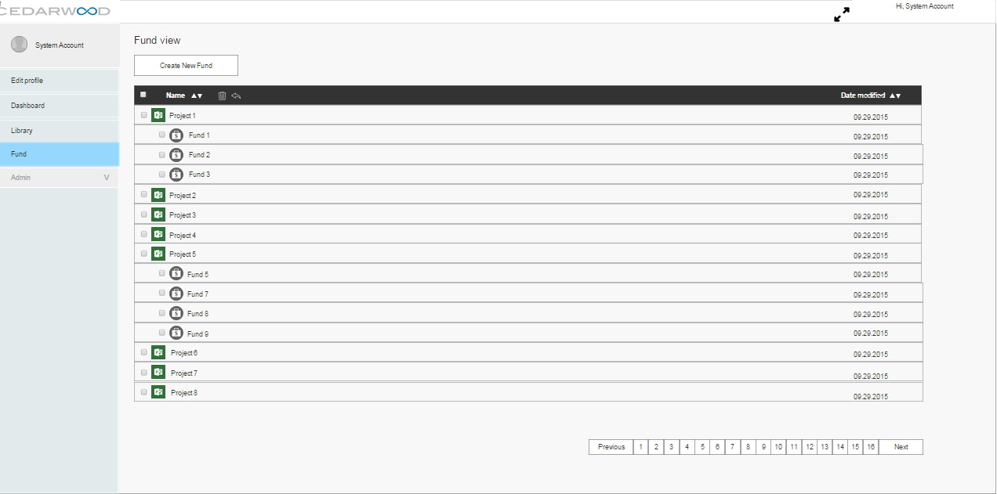

Please, see the wireframe for Fund list view described below:

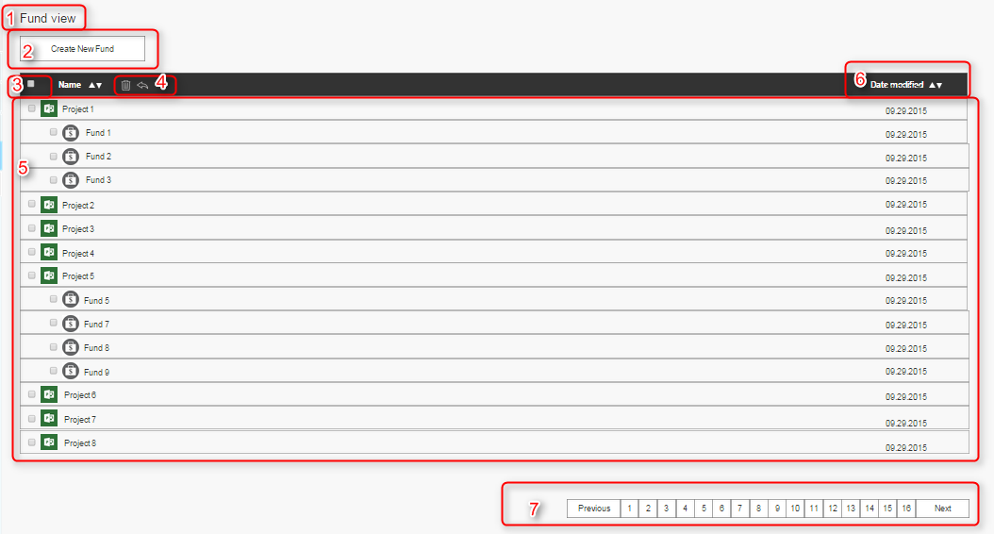

**Table 1. UI description for Fund view list screen**

|  |  |  |  |  |
| --- | --- | --- | --- | --- |
| **Ref #** | **Name of the field**  **(label)** | **Type of control** | **Description** | **UI screenshot** |
| 1 | Fund view | Label | Name of the page on which user is |  |
| 2 | Create Fund | Button | Button to create a new fund |  |
| 3 | No Label | Checkbox | User can select all files in one time/ unselect all files in one time. |  |
| 4 | - | Icon trash;  Icon undo; | User can delete /archive files by click on the trash icon. By clicking on the arrow – the action of delete is undone. |  |
| 5 | List view (no label) | List of project and funds within the project | Describes to which project Fund is assigned.  The list view represents only projects and funds. | Please, see the picture above. |
| 6 | Name;  Date modified; | Filter | User can filter through the Name (in alphabetic order and other way); by date (from earliest/from latest) |  |
| 7 | Previous;  Numbers  Next; | Pages selection | User can go through the list of funds when the list exceeds 1 page view; |  |

### Create new fund

Please, see below a screenshot which illustrates how user can call out the fund creation.

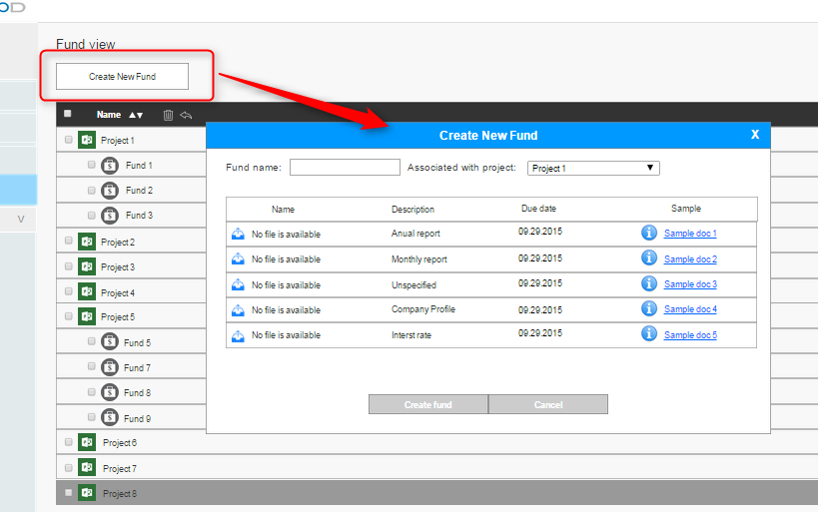

Please, see below the screenshot of Create new fund modal window:

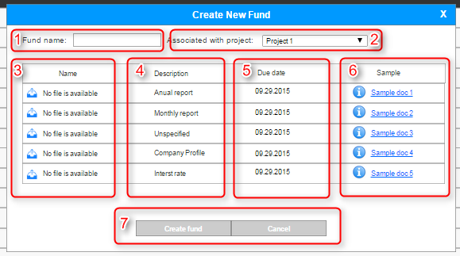

Please, see below the detailed description of the UI within the table:

|  |  |  |  |
| --- | --- | --- | --- |
| **Reference** | **Label/Name** | **Type of control** | **Description** |
| 1 | Fund Name | Text field | Name of the fund |
| 2 | Associated with project | Dropdown list | A list of projects that are available for user and that can be associated with a new fund. |
| 3 | Name (label for a column header) | Column | Column with names of the documents |
| 4 | Description (label for a column header) | Column | Description of the document which need to be uploaded by user. |
| 5 | Due date (label for a column header) | Column | Due date for a document to be uploaded |
| 6 | Sample (label for a column header) | Column | A sample of the document, which can be downloaded by user. |
| 7 | Create fund (label)  Cancel (label) | Buttons | User can save or cancel the changes. |

### Fund view

Please, see below the UI for Fund view:

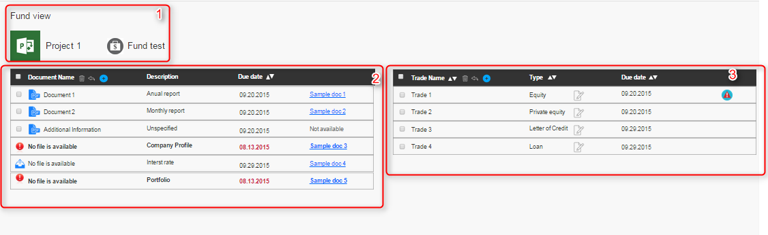

|  |  |  |  |
| --- | --- | --- | --- |
| **Reference** | **Label/Name** | **Type of control** | **Description** |
| 1 | Fund view (label)  Project 1 (label)  Fund test (label) | Label | Fund view – label of the page  Project 1 – label of the project with which the Fund is associated  Fund test – name of the fund |
| 2 | Fund documents list | List | A list of the documents which belong to the current fund |
| 3 | Trade list | List | A list of the trades which belong to the current fund |

Please, see below the description of the list in more details.

#### Fund documents list

Please, see the UI description for the Fund documents list:

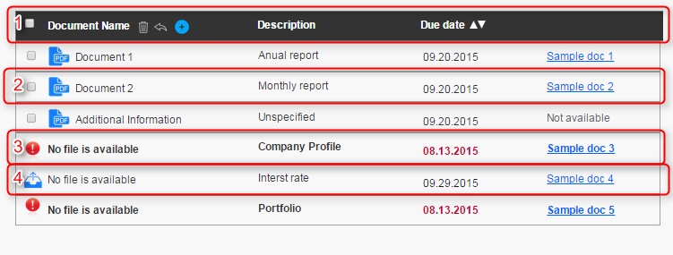

|  |  |  |  |
| --- | --- | --- | --- |
| **Reference** | **Label/Name** | **Type of control** | **Description** |
| 1 | Common functionality:   1. Select all/none 2. Document Name; 3. Delete/ undo delete; 4. Add document; 5. Description; 6. Due date; | L  1.Checkbox  2.Label  3.Button  4.Button  5.Label  6.Label +filter | Provides common functionality for user to operate with documents. |
| 2 | - | Line with uploaded document | User uploaded the Document 2 which has description Monthly report and due date for that document is 09.20.2015. With Sample of the document 2 is available via link. |
| 3 | - | Line with document that is missing and needs to be uploaded **ASAP** | User didn’t uploaded the document which has description Company profile. This document due date is already expiring, so the whole line indicated with bold + red color + icon. All of these tells user to download the document ASAP. |
| 4 | - | Line with document that is missing | User didn’t uploaded the document which has description Interest rate. Due date is OK, so line has no special icons or coloring. User can upload the document by clicking on the upload icon. |

#### Trade list

Please, see below description for the trade list.

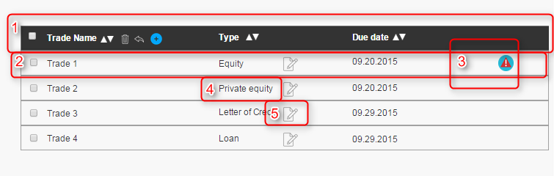

|  |  |  |  |
| --- | --- | --- | --- |
| **Reference** | **Label/Name** | **Type of control** | **Description** |
| 1 | Common functionality:   1. Select all/none 2. Trade Name; 3. Delete/ undo delete; 4. **Add trade**; 5. **Type**; 6. Due date; | L  1.Checkbox  2.Label  3.Button  4.Button  5.Label  6.Label +filter | Provides common functionality for user to operate with trade. |
| 2 | - | Line with trade | Provides user with short description of trade name, type (Equity), possibility to edit, due date for this trade, any additional information. |
| 3 | Alert : your attention is needed for this trade | Icon | Provides user with notification/alert that something is wrong with the trade, i.e. some important documents are missing, or due date for the documents turn in is close. |
| 4 | Name of the trade type | Label | Description of the trade type |
| 5 | Edit trade | Button | Provides user with possibility to edit trade. Opens trade editor by click. |

#### Create new trade

Please, see below the description of the Create new modal window.

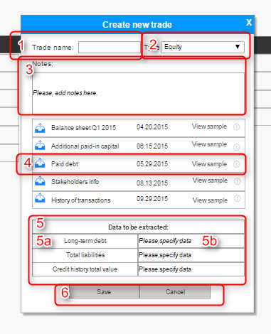

|  |  |  |  |
| --- | --- | --- | --- |
| **Reference** | **Label/Name** | **Type of control** | **Description** |
| 1 | Trade name | Text field | Name for a new trade |
| 2 | Type of trade | Dropdown list | Trade type definition. Depending on this type set of documents that need to be provided by user are specified. |
| 3 | Notes | Text field | A short description which user can provide regarding this trade. |
| 4 | - | Line with document and its description |  |
| 5 | Data extraction | Table | 5a. Label which indicates what data to be extracted.  5b. Value/data which need to be specified by user. |
| 6 | Save/Cancel | Control buttons | User can save/cancel the trade creation |

#### Modify trade

The Modify trade modal window shall be reused and have the same description as Create new trade modal window. Still, there is some behavior, which is illustrated below:

1. The Trade editor view:

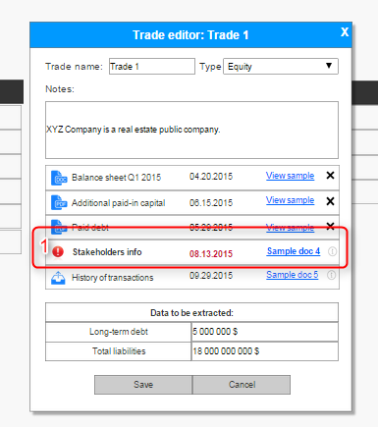

You can see that in the trade view editor the list of documents which need to be uploaded indicated with red color & icon (same as in the list of the fund documents). This notification is also visible from the trade list view (ref 3 Alert icon).

1. Delete one document from the list

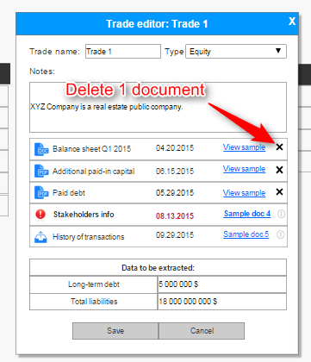

Use can delete one of the uploaded files. If the document is required for this type of trade, after user deleted it, the initial state (as in create new trade) line shall be provided.

1. Edit trade type (change from Equity to Loan)

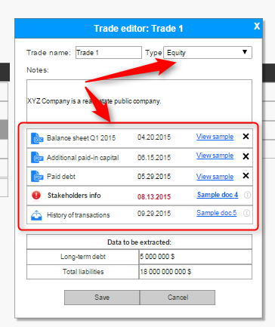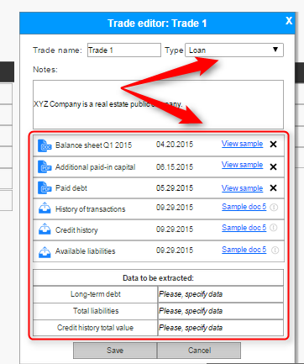

When user modifies trade type, this triggers UI changes: required documents view, and data to be extracted.